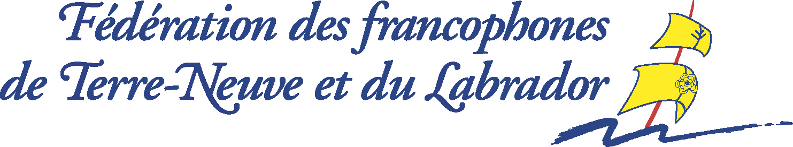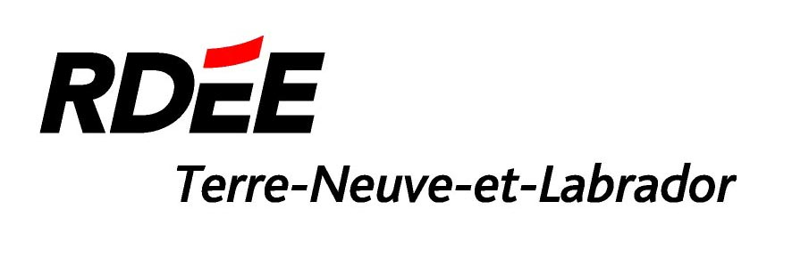

For immediate release

Press Release

Newfoundland and Labrador Photography Contest Winners Announced

St. John’s (Newfoundland and Labrador), October 20th, 2008 – The Réseau de développement économique et d’employabilité de Terre-Neuve-et-Labrador (RDÉE TNL) and the Fédération des francophones de Terre-Neuve et du Labrador (FFTNL) are pleased to announce the three winners of their photo contest to embellish their 2009-2010 French Language Travel Guide for Newfoundland and Labrador & Saint-Pierre et Miquelon and increase their bank of photos.

The three winners who will receive a cash prize are:
- 1st prize of $400: Don Wells from Botwood, Newfoundland and Labrador
- 2nd prize of $ 100: Evan Burt from Paradise, Newfoundland and Labrador
- 3rd prize of $50: Shane Howard from Mount Pearl, Newfoundland and Labrador

To see the photos of the three winners, visit www.francotnl.ca/concours-photos-2008.

“We would like to congratulate the winners and thank all the participants. We have received close to 200 photos; it is much beyond our expectations. We are delighted by the quality of the photos we have received”, says Josée Dalton, Executive Director of the RDÉE TNL.

These three photos will be published in the 2009-2010 French Language Travel Guide for Newfoundland and Labrador & Saint-Pierre et Miquelon. The purpose of the contest was also to increase the bank of photos of the RDÉE TNL and the FFTNL in order to publish a very visual guide. That is why other photos received during the contest will be used in the guide, in other promotional publications and on the Francophone Newfoundland and Labrador web portal.

The RDÉE TNL and the FFTNL, in collaboration with the firm HuVo, will publish the fifth annual French Language Travel Guide for Newfoundland and Labrador & Saint-Pierre et Miquelon at the beginning of 2009. The guide, 40,000 copies, will be distributed in Canada, France, Belgium and North Africa. The publication of the guide is possible thank to financial contributions of Canadian Heritage, the provincial Tourism Department, the Atlantic Canada Opportunities Agency (ACOA) and the Comité régional du tourisme.

– 30 –

Information:
Frédérique Weiland, RDÉE TNL
Telephone: (709) 726-5973
Email: tourisme@rdeetnl.ca

